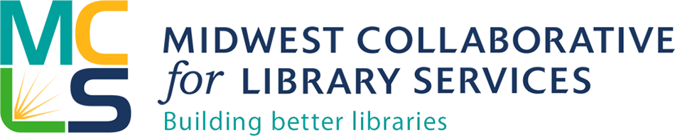

MCLS Indiana Grant Application

Project: Consulting services for strategic planning

Deadline: February 15, 2017

Submit completed application by email to Michelle Bradley, MCLS Member Engagement Manager at bradleym@mcls.org

Information about your library
- Name of Library
- Address
- Phone
- Library Director Name
- Population Served
- Website

Narrative

- Describe your community including geography, socio-economic characteristics, ethno cultural make up, and other relevant information.
- Describe why this opportunity interests you and your library
- Describe your ability/capacity to work with the consultant over a four-month period in 2017. Do you have board support to undertake a strategic planning process? Do you have a current or past strategic plan? How successful was it? Do you have staff/board members willing to serve on the planning committee? How important is engaging the community in your planning process?

Authorization

Authorizing Official Information
- Authorizing Official First Name
- Authorizing Official Last Name
- Email Address
- Phone Number
- Title
- Organization
- Certification—By checking this box and submitting this application, the authorized representative for the applicant organization certifies that all statements contained herein are true and correct to the best of their knowledge and belief. _____________
- By checking this box and submitting this application, the authorized representative for the applicant organization certifies that if selected to receive the strategic planning consulting services, they will work with MCLS over the specified time period _______________

